Adjacency matrix

9  0 0 0 0 1 1 1 0 1  0 0 0 0 0 0 1 0 1  0 0 0 0 0 0 0 1 0  0 0 0 0 0 0 0 1 0  1 0 0 0 0 1 0 0 1  1 0 0 0 1 0 0 0 1  1 1 0 0 0 0 0 0 0  0 0 1 1 0 0 0 0 0  1 0 0 0 1 1 0 0 0 | 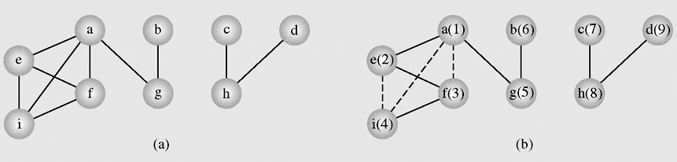

int [][] b =
{
{0, 0, 0, 0, 1, 1, 1, 0, 1},
{0, 0, 0, 0, 0, 0, 1, 0, 1},
{0, 0, 0, 0, 0, 0, 0, 1, 0},
{0, 0, 0, 0, 0, 0, 0, 1, 0},
{1, 0, 0, 0, 0, 1, 0, 0, 1},
{1, 0, 0, 0, 1, 0, 0, 0, 1},
{1, 1, 0, 0, 0, 0, 0, 0, 0},
{0, 0, 1, 1, 0, 0, 0, 0, 0},
{1, 0, 0, 0, 1, 1, 0, 0, 0}
};

